**WIND REVIEW**  **Name:_____________________________________**

1. What happens to air when it is heated? How is this related to the air’s density?
2. What happens to air when it is cooled? How is this related to the air’s density?
3. Based on your answers to questions 7 and 8, what causes air to move?
4. What is the Coriolis Effect?
5. What three factors influence the global wind patterns drawn on your plate?
6. What causes the jet streams?
7. Explain how the jet stream in each diagram influences weather in Georgia.

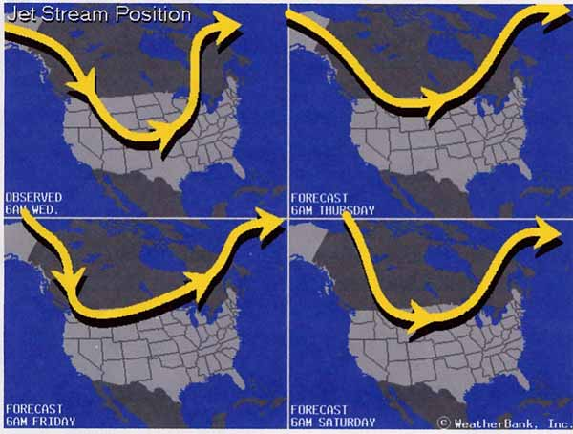

2

1

4

3

1. 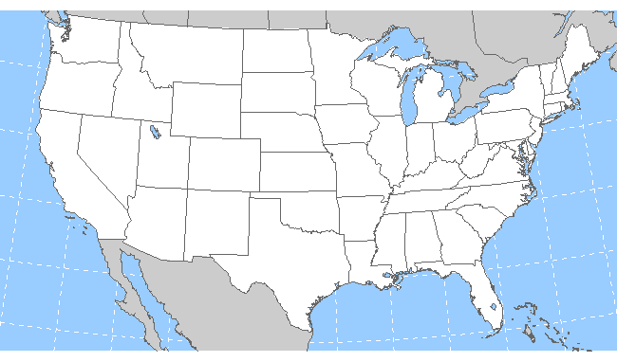Complete the drawing to show the position of the jet stream if the air over Georgia is extremely cold.
2. Why does most of our weather in Georgia move across the United States from West to East?

10. Complete a color drawing of Sea Breezes and Land Breezes. Be sure the warm air and cool air is **labeled**, and is in **color for each drawing**.

|  |  |
| --- | --- |
| **Sea Breeze** | **Land Breeze** |

1. During a sea breeze, where would the warmest air be located and **why** is it located there?
2. During a land breeze, where would the warmest air be located and **why** is it located there?
3. What would have to be happening for there to be little or no breeze at the beach? What time of day could this occur? (Think about what creates wind…)