Name ___________________________
Metric Conversions

Fill in the boxes in the stair step diagram.
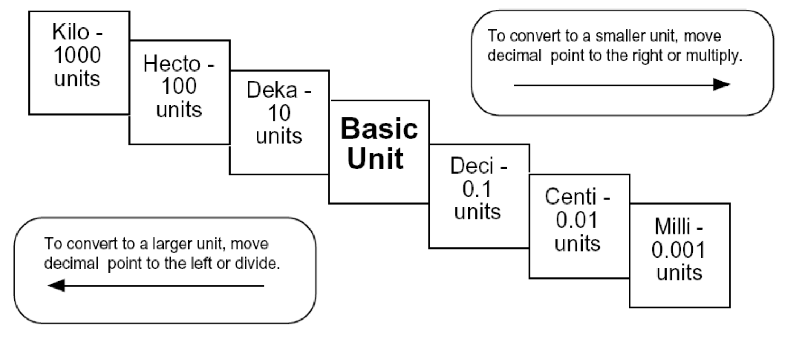

Try these conversions using the ladder method.
1000 mg = _______ g 1 L = _______ mL 160 cm = _______ mm
14 km = _______ m 109 g = _______ kg 250 m = _______ km

Compare using <, >, or =.

56 cm 6 m 7 g 698 mg

T. Trimpe 2008 http://sciencespot.net/

Name ___________________________
Metric Conversion Practice

Write the correct abbreviation for each metric unit.
1) Kilogram _____ 4) Milliliter _____ | 7) Kilometer _____
2) Meter _____ 5) Millimeter _____ | 8) Centimeter _____
3) Gram _____ 6) Liter _____  Try these conversions, using the ladder method. | 9) Milligram _____
10) 2000 mg = _______ g 15) 5 L = _______ mL | 20) 16 cm = ______ mm
11) 104 km = _______ m 16) 198 g = _______ kg | 21) 2500 m = ______ km
12) 480 cm = _____ m 17) 75 mL = _____ L | 22) 65 g = _____ mg
13) 5.6 kg = _____ g 18) 50 cm = _____ m | 23) 6.3 cm = _____ mm
14) 8 mm = _____ cm 19) 5.6 m = _____ cm  Compare using <, >, or =. | 24) 120 mg = _____ g
- 63 cm 6 m 27) 5 g 508 mg 29) 1,500 mL 1.5 L
- 536 cm 53.6 dm 28) 43 mg 5 g 30) 3.6 m 36 cm

Challenge: Create three conversion problems for your classmates along with the correct answers.

T. Trimpe 2008 http://sciencespot.net/

